Technical Report
Assignment 1: Ecosystem Simulation

Emergence
One behaviour that I did not explicitly code was how the population of herbivores and the number of food initially increased, then decreased significantly, while the population of carnivores increased until it reached equilibrium. After such, all three begin fluctuating around the equilibrium.

Evolutionary Trends
In the program, each gene of the herbivores and carnivores was initialized as a random value within its range. Additionally, during reproduction, they all had a small percentage of mutating their genes, in either direction, by 10% (bounded by a certain range). However, every gene of both animals experienced an overall increase compared to the beginning. Notably, carnivores experienced a higher increase in size, reaching almost 1.6 units (the upper limit) after 1000 seconds, while the herbivores reached approximately 1.3 units. In contrast, herbivores showed a greater increase in max speed, reaching about 4.4 units (4.5 is the upper limit), while carnivores showed a much smaller increase, reaching 3.25 units.
This shows how the herbivores tend to go for the small and fast route, while the carnivores go for larger sizes. It also illustrates the Theory of Evolution by Natural Selection. Over time, herbivores, on average, become faster to better evade carnivores (Fig. 1). On the contrary, the carnivores become bigger in size and are better able to kill prey of larger sizes (Fig. 2).

Figure 1. Mean speed of herbivores and carnivores with respect to time

Figure 2. Mean speed of herbivores and carnivores with respect to time

Performance Analysis
At around 900 – 1000 herbivores and carnivores (excluding producers), in Quadtree mode, it reaches 60 FPS with some drops to 30 FPS. However, in Naïve / non-optimised modes, it can drop below 20 or even 10 FPS.
According to Firefox Profiler, the most expensive functions (in Quadtree mode) are the show() methods of the classes Herbivore and Food, as well as the query method of the class Herbivore. However, when the mode switches to naïve mode, the query methods jump to about 90% or higher of all processes.
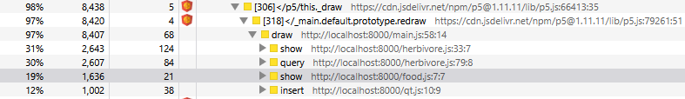
Figure 3. Performance analysis of the program in Quadtree mode
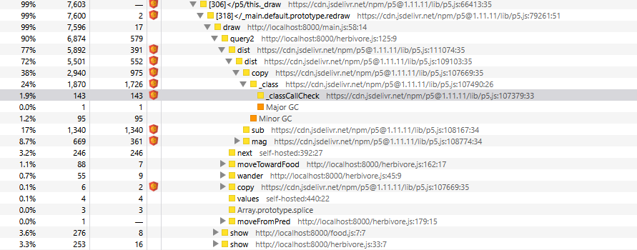
Figure 4. Performance analysis of the program in Global1 mode
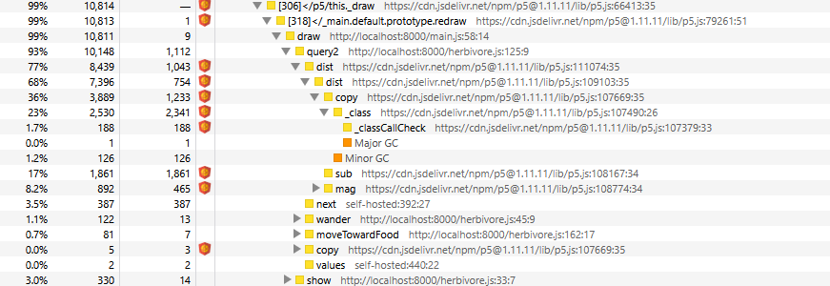
Figure 5. Performance analysis of the program in Global2 mode

